**BT305 Lab Assignment 6**

**Name: Sumit Kumar**

**Roll No. 210106076**

**Model 1: Major Cold shock protein from Staphylococcus aureus**

Comparison between Homologue and Modweb (RMSD=0.852)

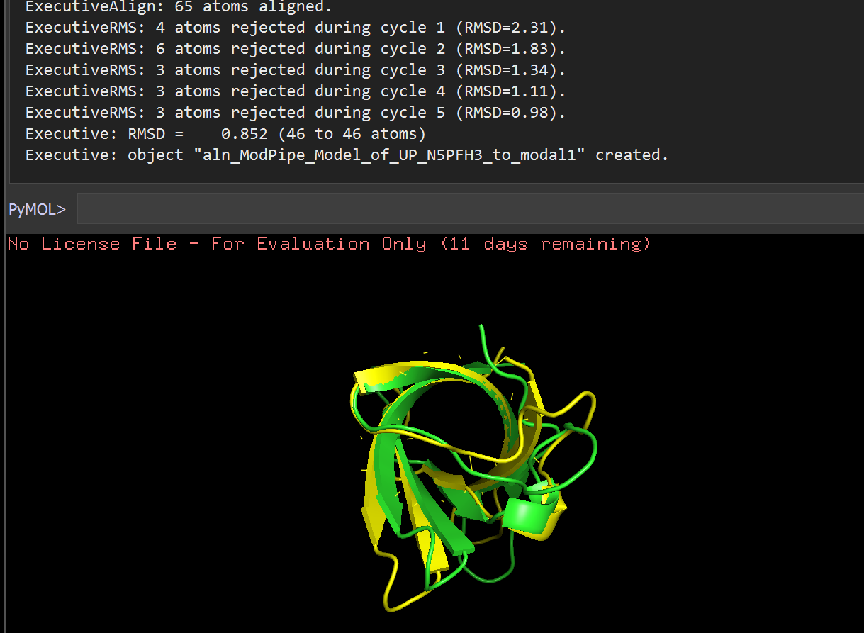

Comparison between Homologue and Swiss (RMSD=0.351)

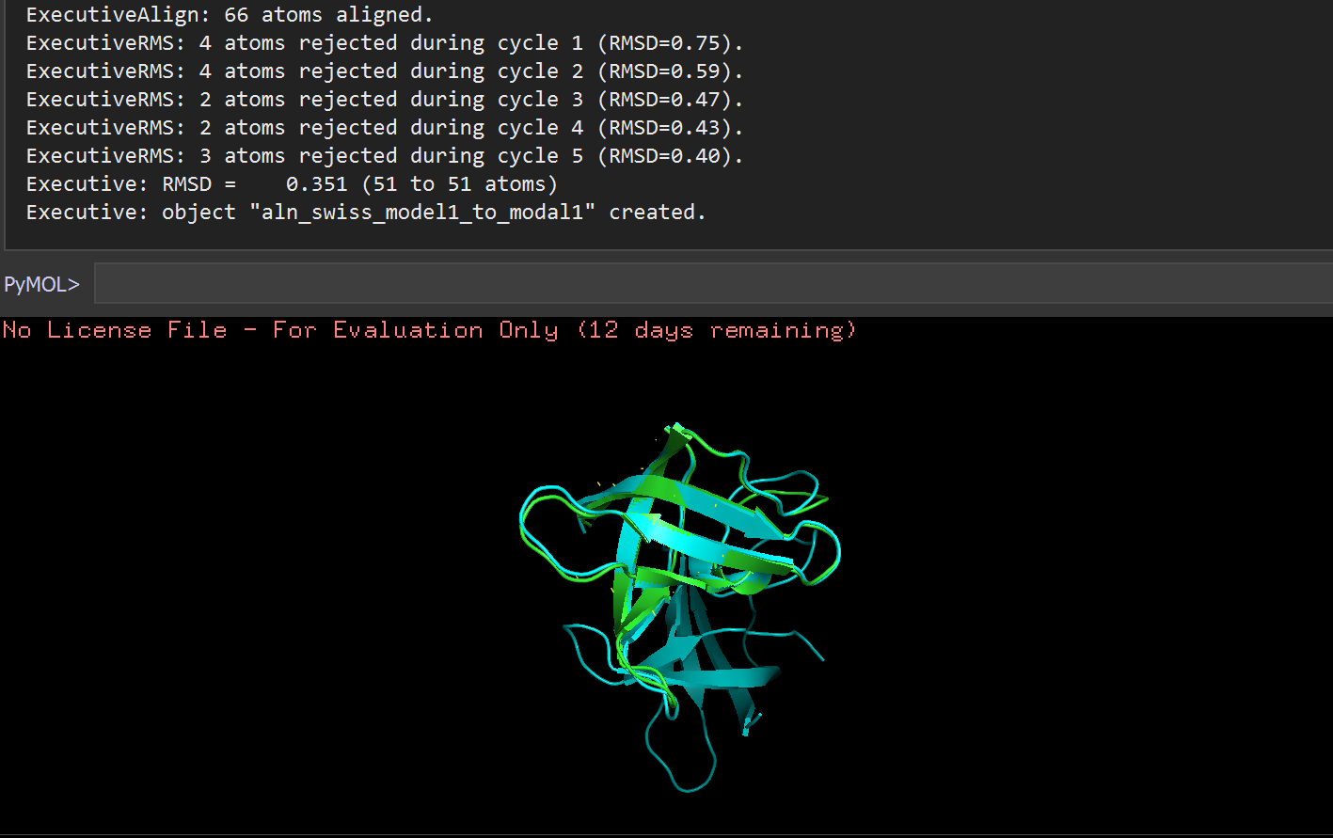

Comparison between Modeweb and Swiss (RMSD=1.173)

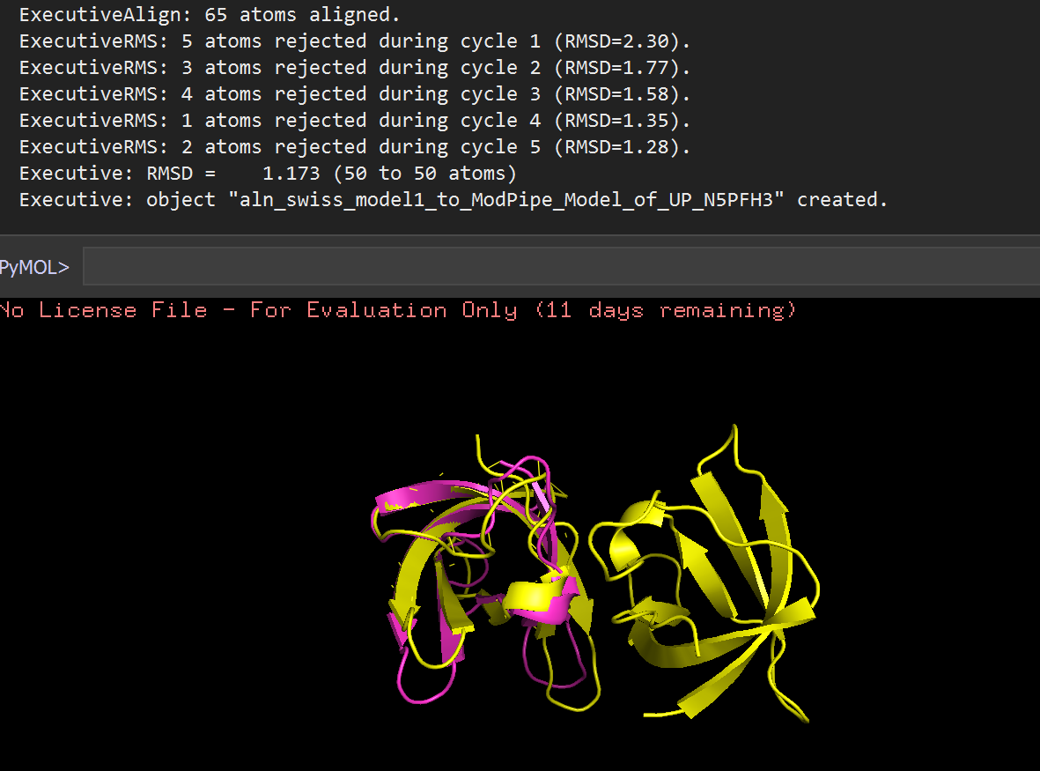

**VAST Graph**

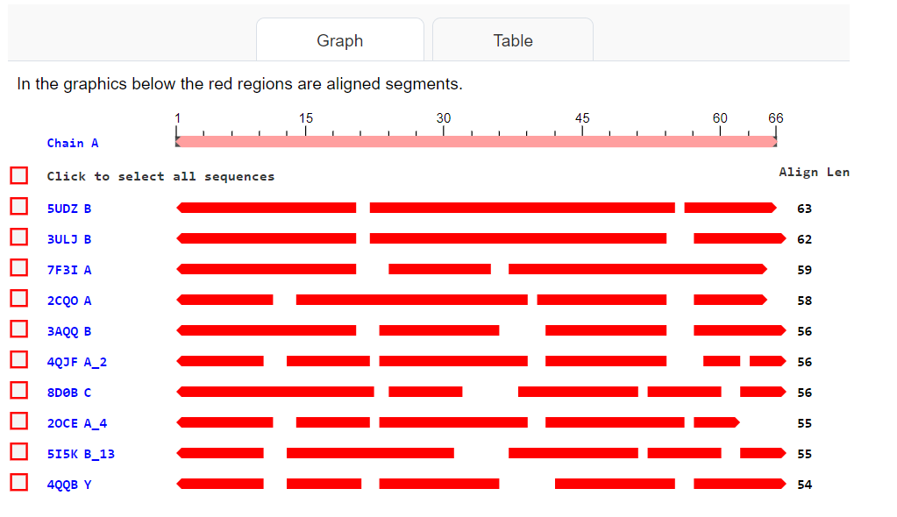

**VAST Table**

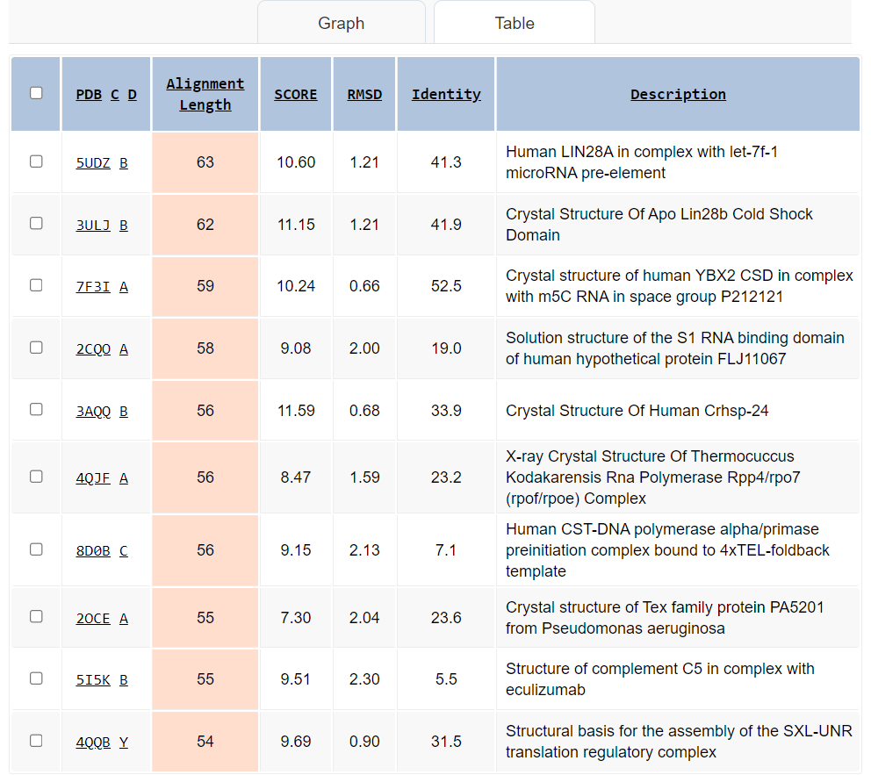

**Model 2: Antifreeze protein from Pachycara brachycephalum**

Comparison between Homologue and Modweb (RMSD=1.311)

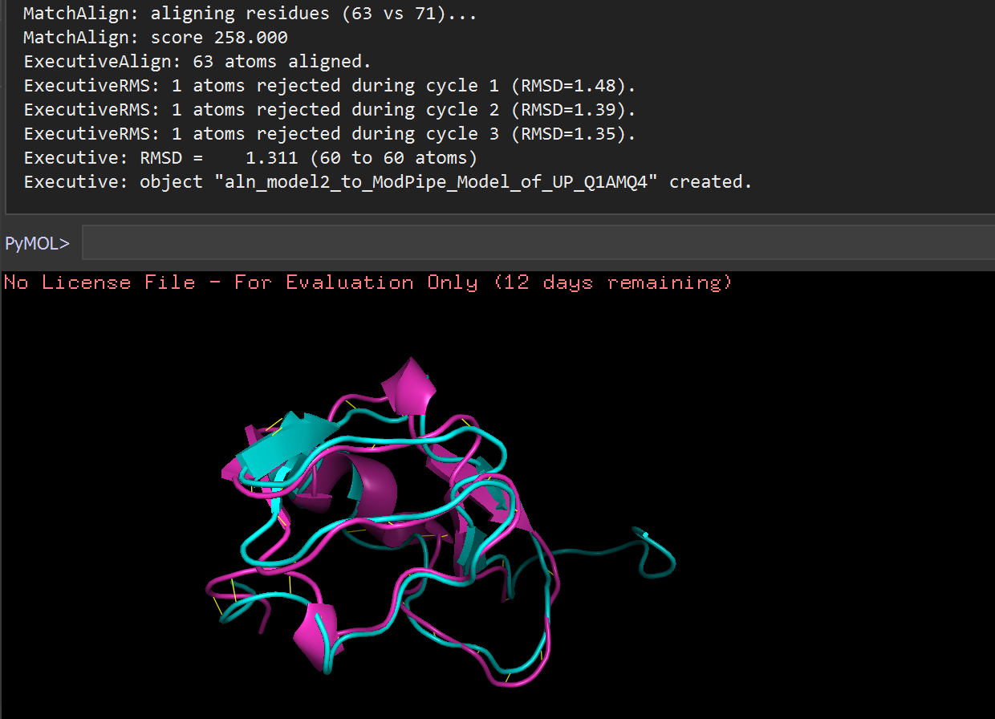

Comparison between Modweb and Swiss (RMSD=1.341)

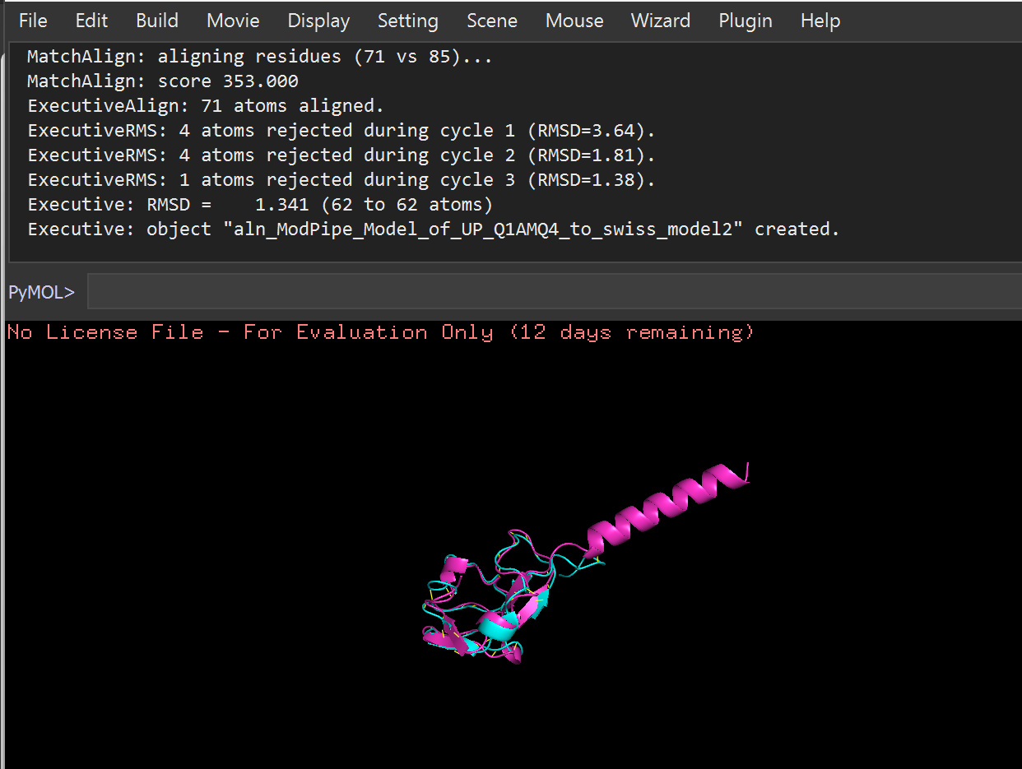

Comparison between Homologue and Swiss (RMSD=0.207)

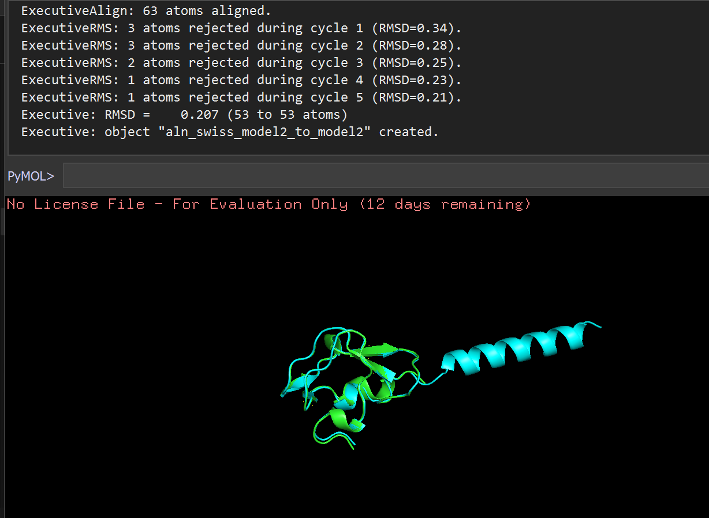

**VAST Graph**

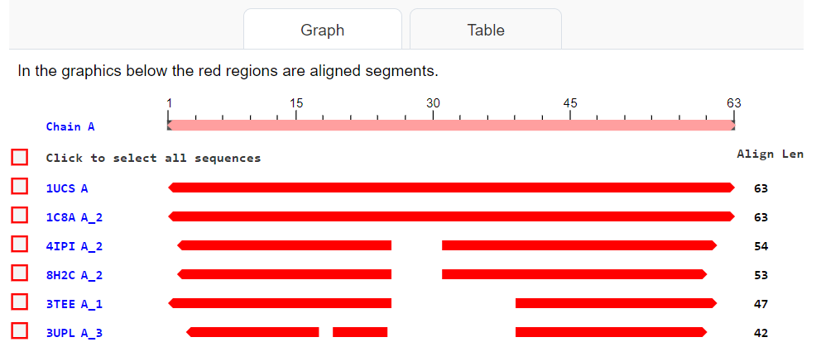

**VAST Table**

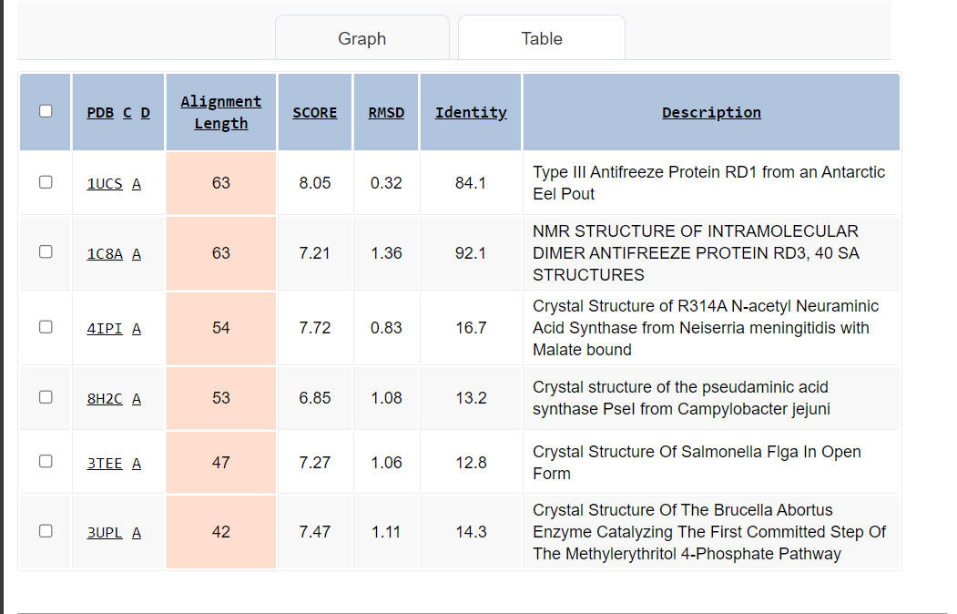

**Model 3: Dihydrofolate Reductase from Vibrio cholerae**

Comparison between Homologue and Modweb (RMSD=0.390)

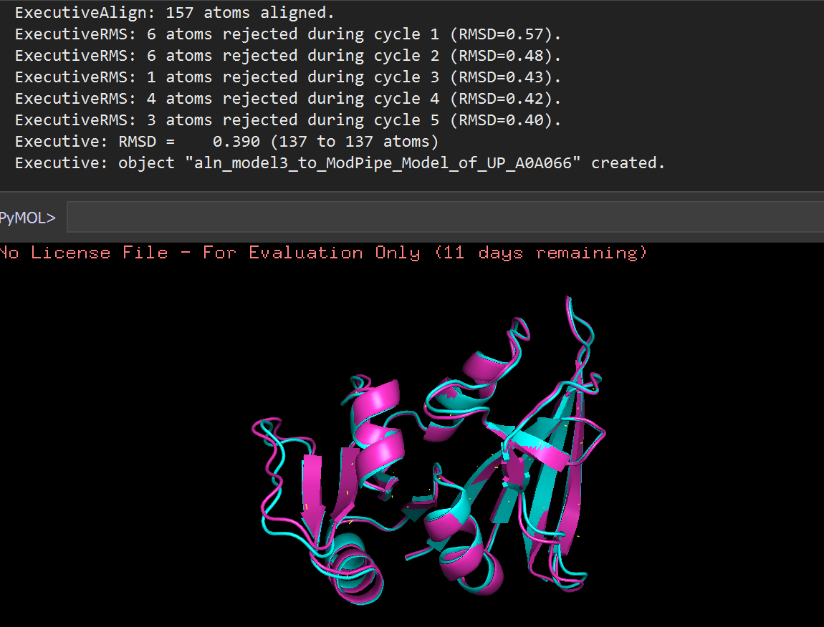

Comparison between Modweb and Swiss (RMSD=0.099)

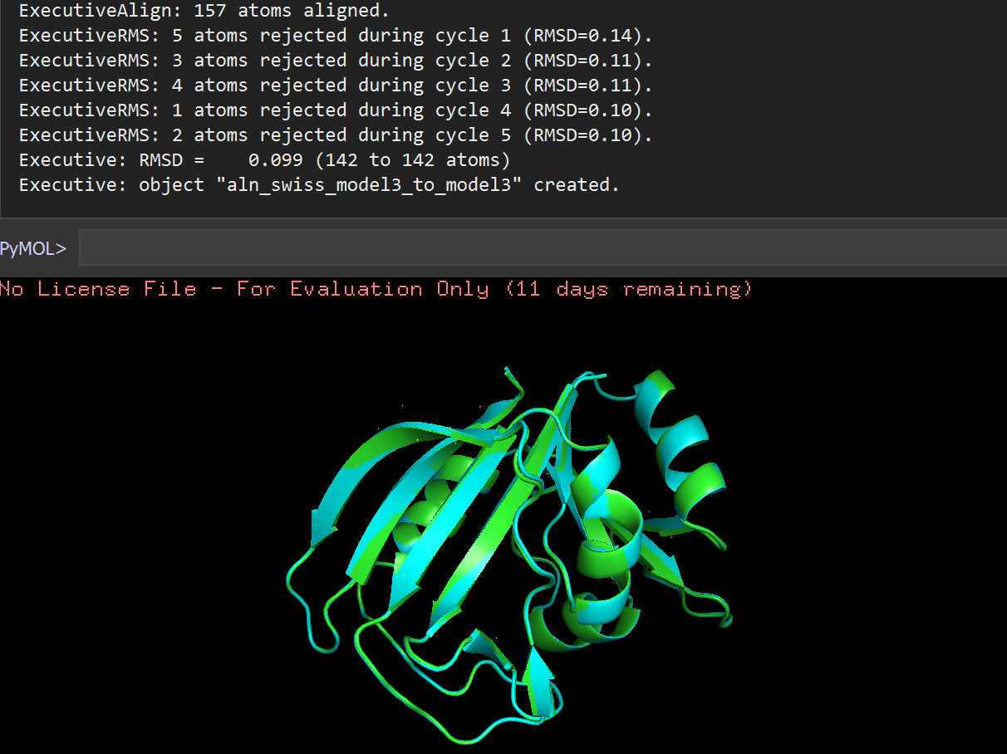

Comparison between Homologue and Swiss (RMSD=0.383)

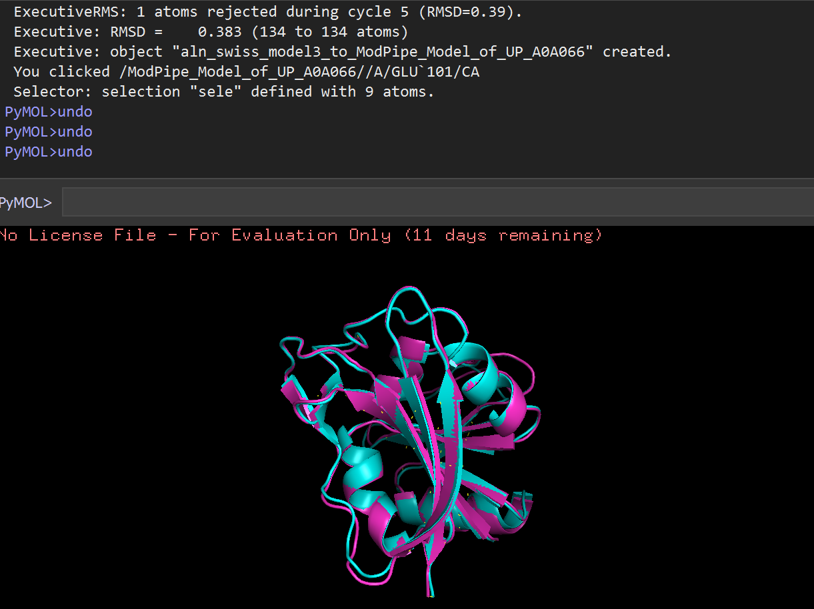

**VAST Graph**

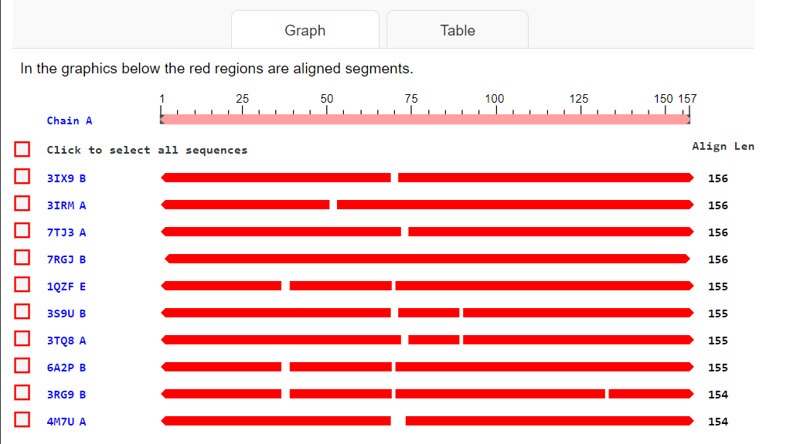

**VAST Table**

